**PRACTICAL-8**

Assume, JK Enterprises hired a number of new employees to work in the Development department. A new identity feed (service) will be created to load these new employees into IBM Security Identity Manager. To load new employees, a Directory Services Markup Language (DSML) file is used

## **DSML Identity Feed services**

The IBM Security Identity Manager Server allows for integration of various human resource (HR) type data feeds. You can add large numbers of individuals to the IBM Security Identity Manager Server without manually adding each individual. An identity record in HR data becomes an instance of a person object in IBM Security Identity Manager. One type of HR type data feed is the DSML Identity Feed service. The service can receive the information in one of two ways: a reconciliation or an unsolicited event notification through an event notification program.

The mechanisms that handle HR data in IBM Security Identity Manager requires that the HR data be in an XML format. The format uses the standard schema defined by the Directory Services Markup Language (DSML version 1). See the DSML website at http://www.oasis-open.org for DSMLv1. When sending asynchronous notifications, an XML message format defined by the Directory Access Markup Language (DAML version 1) is used. DAML is an XML specification defined by IBM that allows specification of add, modify, and delete operations.

DSML file format:

<entry dn="uid=sparker">

<objectclass><oc-value>inetOrgPerson</oc-value></objectclass>

<attr name="givenname"><value>Scott</value></attr>

<attr name="initials"><value>SVP</value></attr>

<attr name="sn"><value>Parker</value></attr>

<attr name="cn"><value>Scott Parker</value></attr>

<attr name="telephonenumber"><value>(919) 321-4666</value></attr>

<attr name="postaladdress"><value>222 E. First Street Durham, NC 27788</value></attr>

</entry>

**Tasks to be done:**

Creating a Directory Services Markup Language (DSML) identity feed

1. First review the contents of development.dsml to confirm that the data looks correct.
   1. Open it in the Text Editor Icon from the desktop.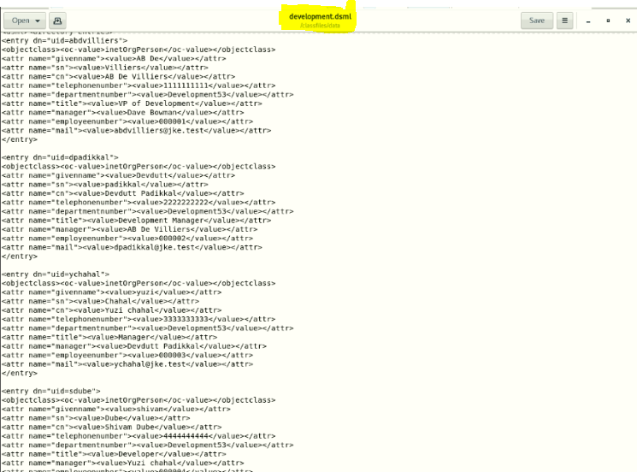
2. On the Home tab, you go to Manage Services.
   1. Login in isim console with itim manager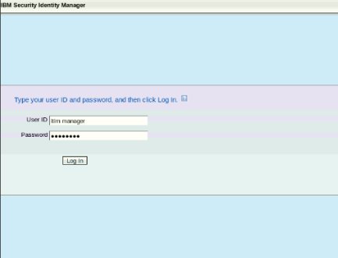
   2. Manage Services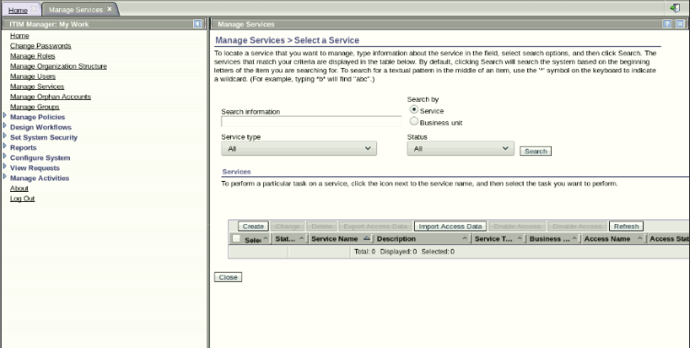
3. Click Create.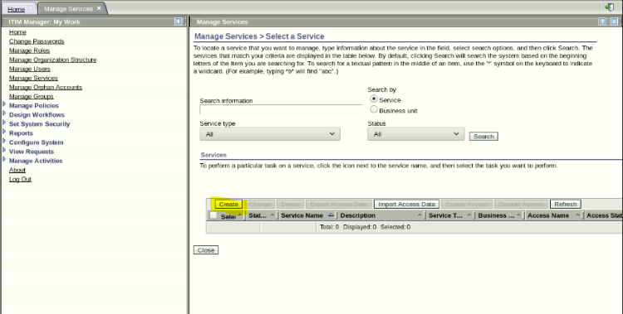
4. Select the Development53 business unit. Click Search in front of the Business Unit and Select Development53.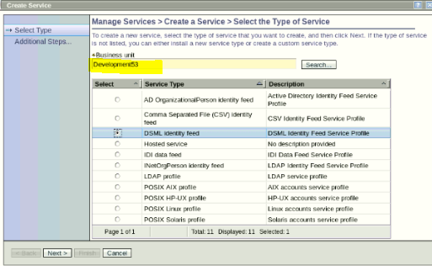
5. Select DSML identity feed and click Next.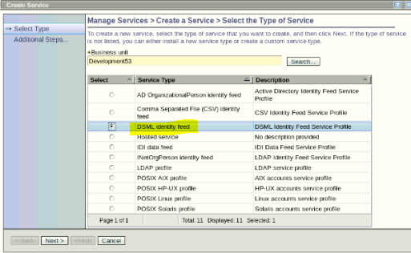
6. Complete the Create a Service form with the following information: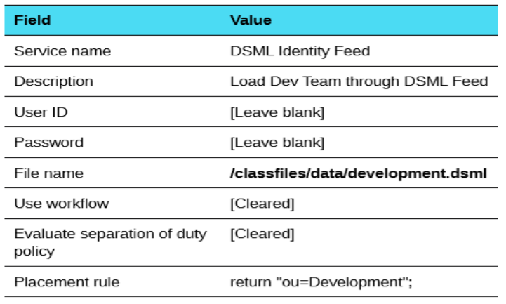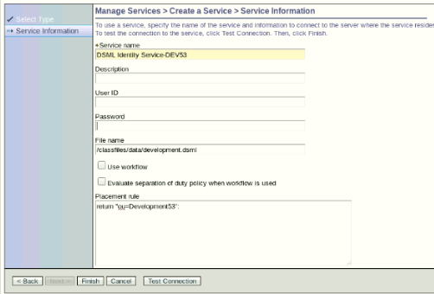
7. Click Test Connection .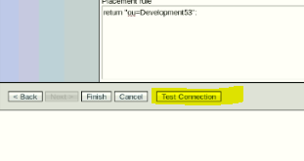
8. If the connection is successful, click Finish. If it is not, check that you entered the file name correctly.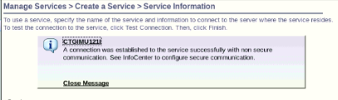
9. When you see the message that you successfully created the DSML identity feed,click Close.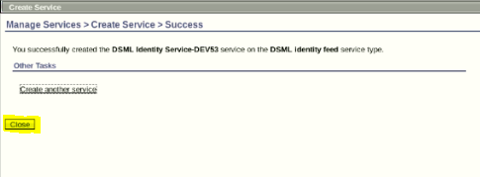
10. From Manage Services > Select a Service, click Refresh until the new service is shown in the list.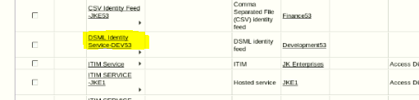
11. Click the small triangle to the right of the new service name and click Reconcile Now. 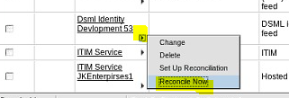
12. When you see the message that you successfully submitted a reconciliation request, click View my request. The reconciliation request should be the top-most request in the list.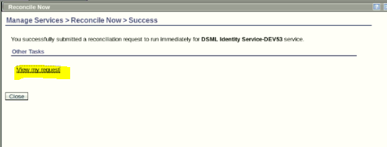
13. If the status of the request is pending (wait for a minute), click Refresh until it shows success.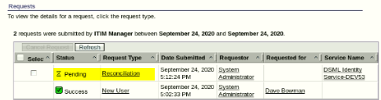
14. On the Home tab, navigate to the Manage Users area. Confirm that four new users are added to the Development business unit.